# “**First DAPP**”

Asjad Iftikhar

18L-0951

Blockchain

Assignment 2

**Task 1:**

-> Software Installation

* Install Virtual Box

* Install Ubuntu Linux

Solution: I use Pop-OS(Linux) as my primary OS of choice, so these steps are redundant and unnecessary for me:

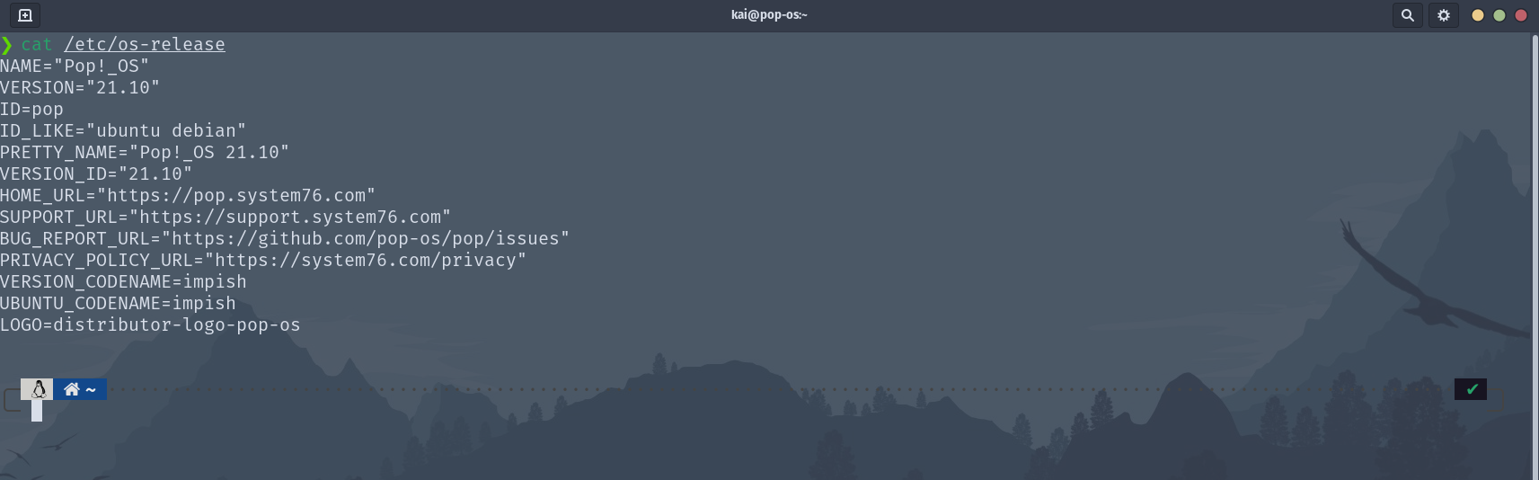

------------------------------------------------------------------------

**Task 2**:

-> Setting up the development environment:

Successfully  setup Development Environment [See Attached]

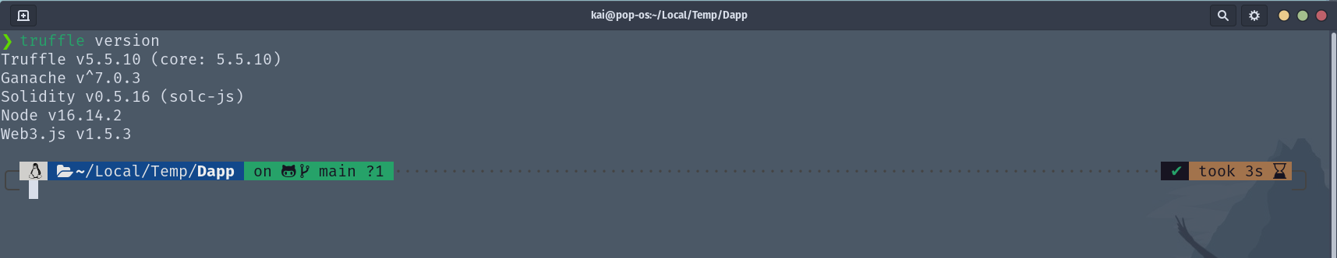

-> Creating a Truffle project using a Truffle Box

Truffle project created using Truffle Box [See Attached]

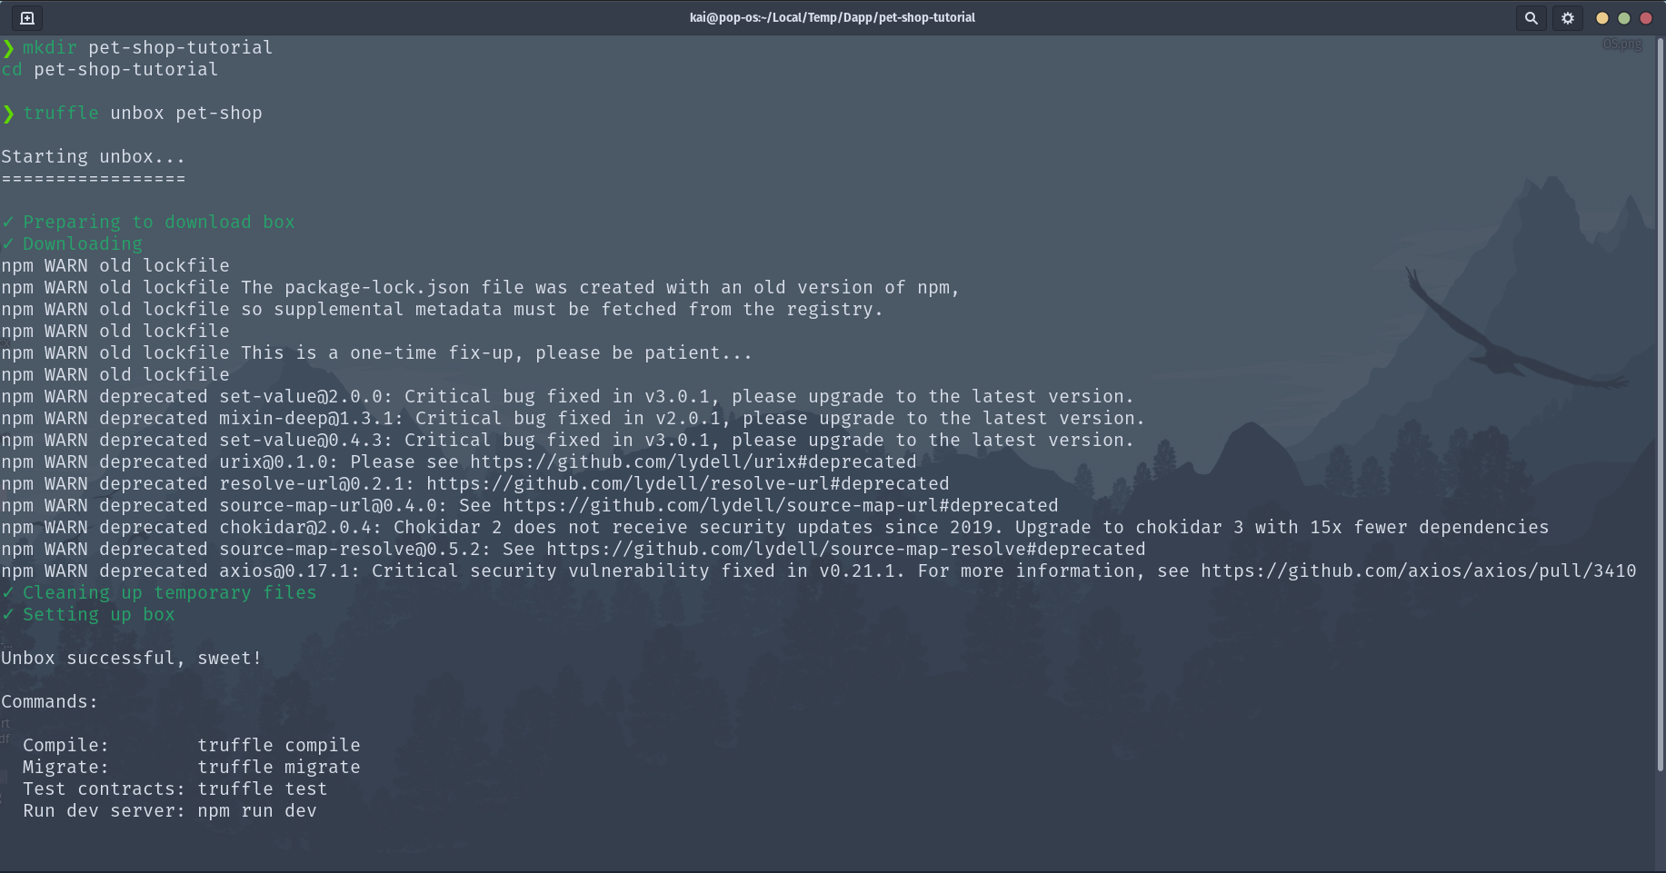

------------------------------------------------------------------------

Task 3:

-> Writing the smart contract

Contract Added in contracts/

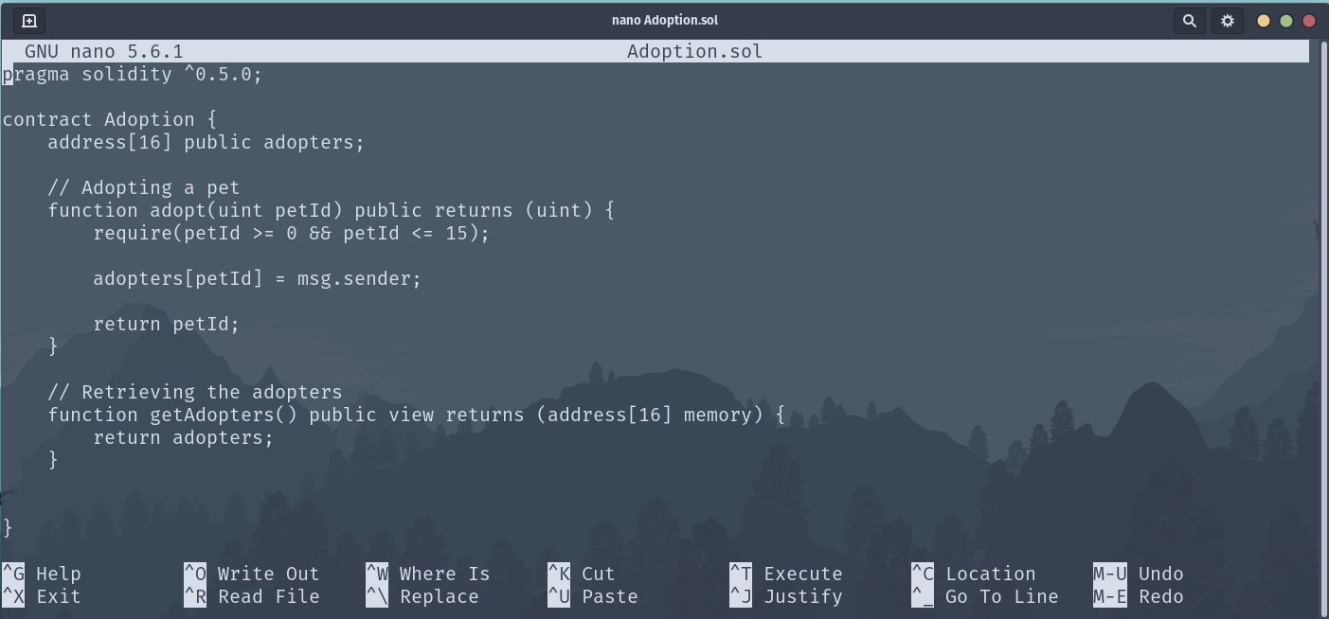

-> Compiling and migrating the smart contract

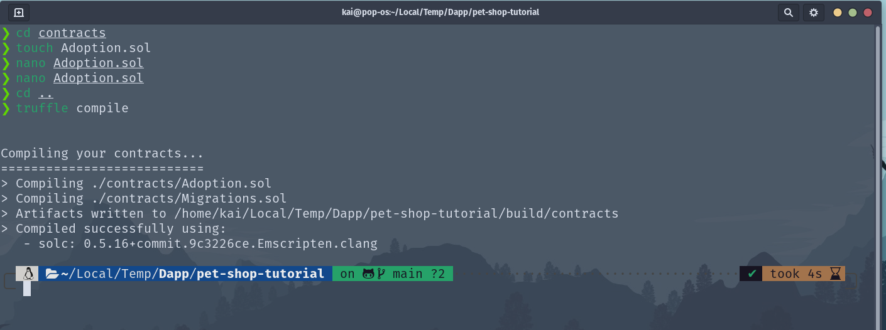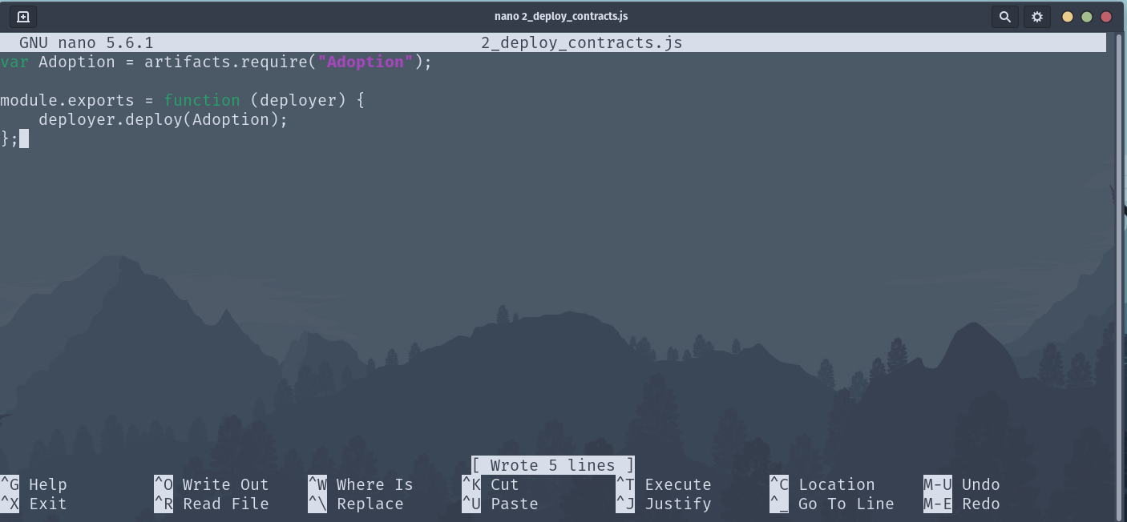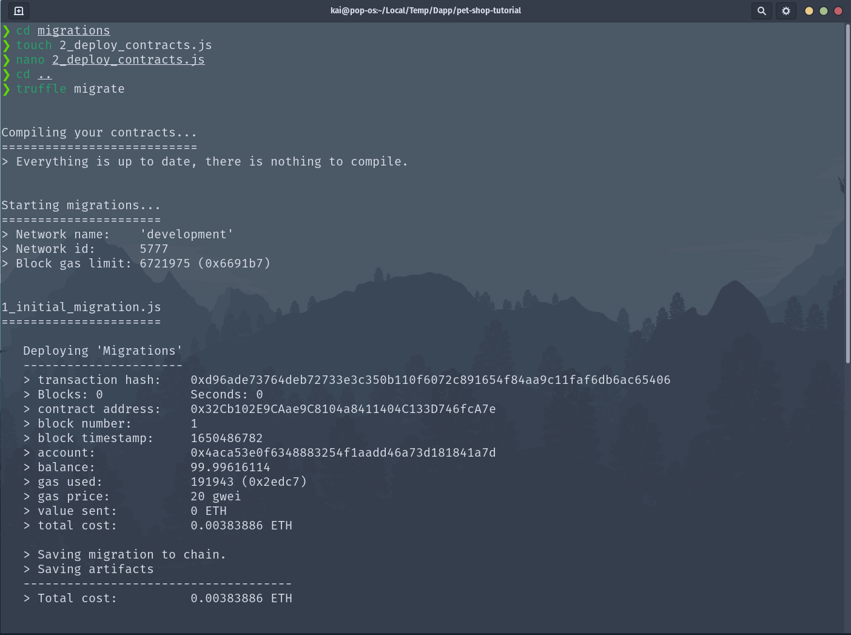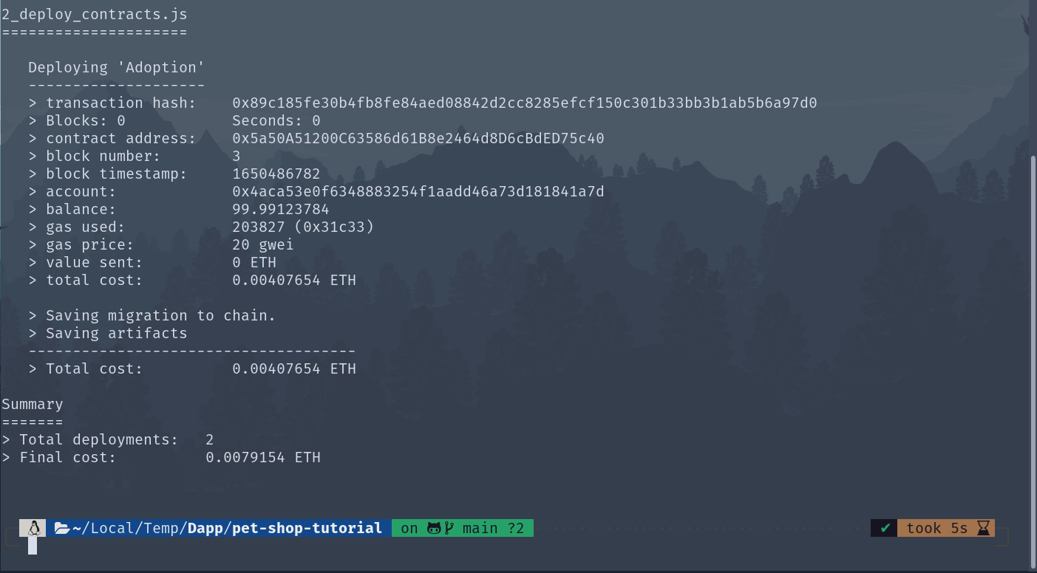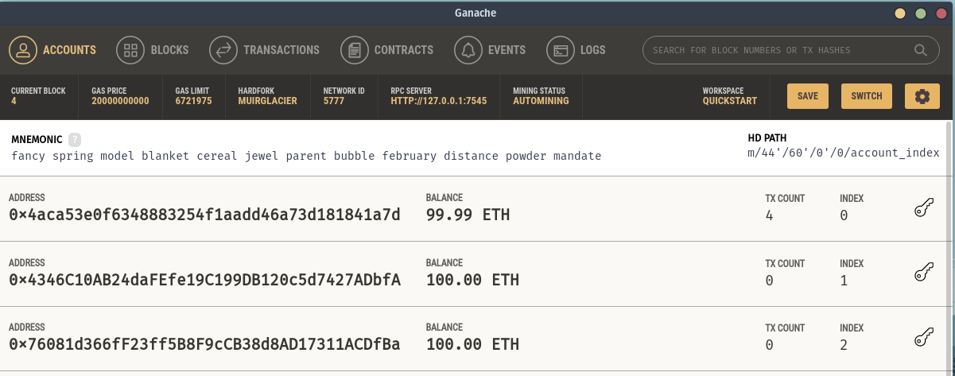

-> Testing the smart contract

Write Test in test/

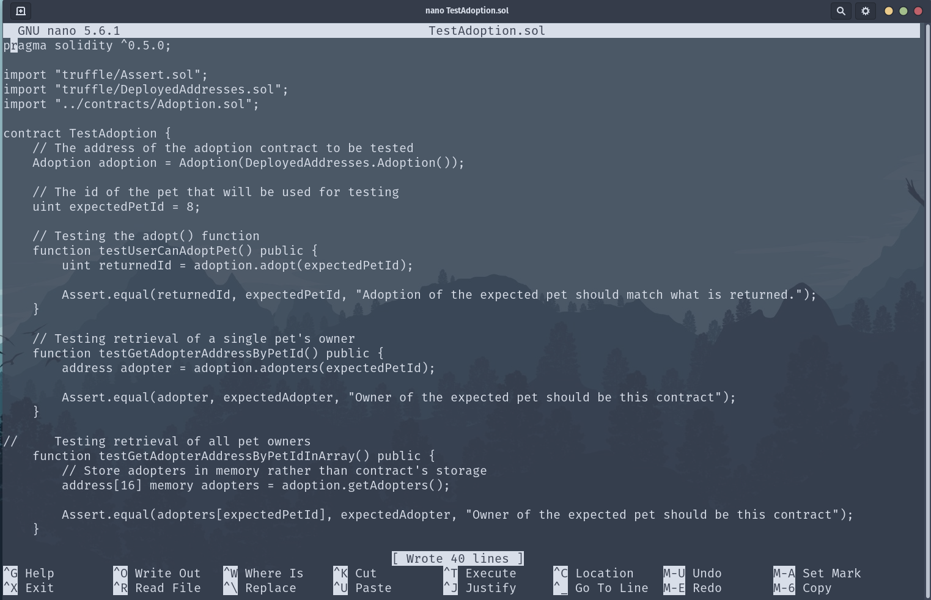

Perform test:

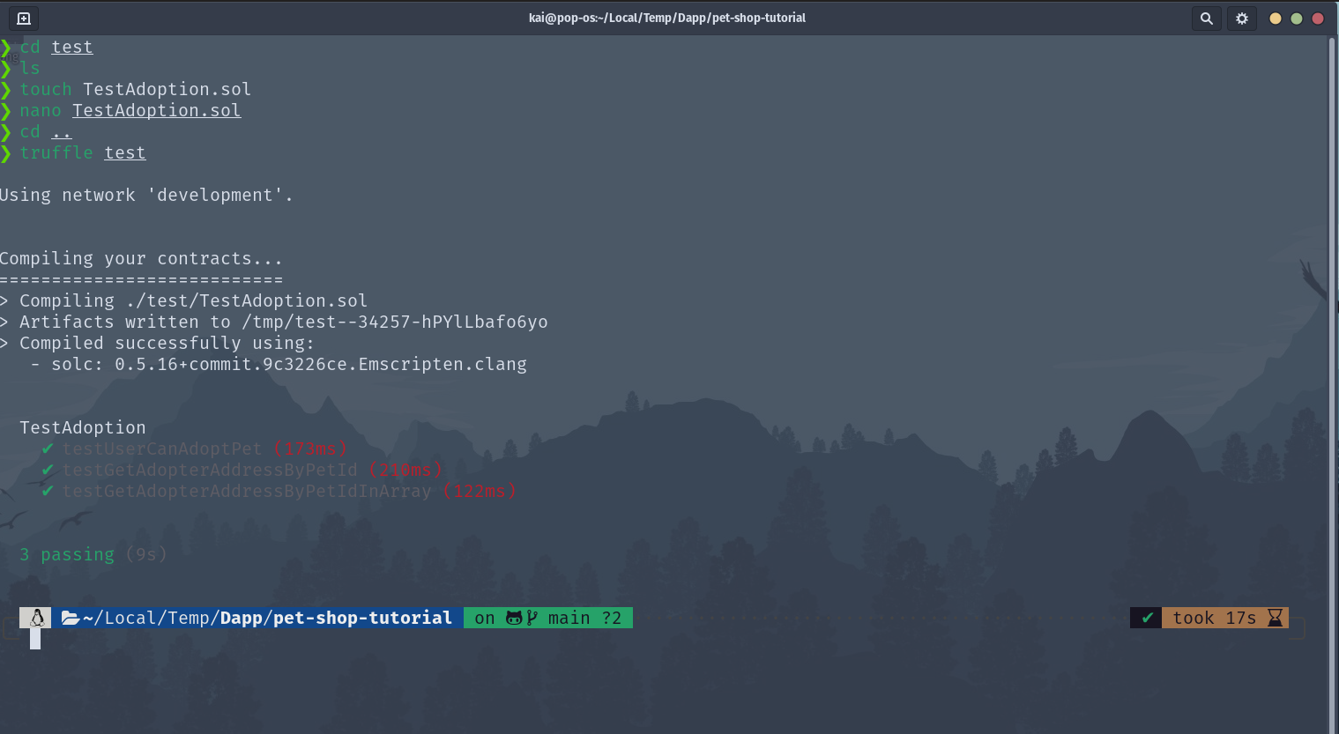

------------------------------------------------------------------------

Task 4:

-> Creating a user interface to interact with the smart contract

 Add UI Code:

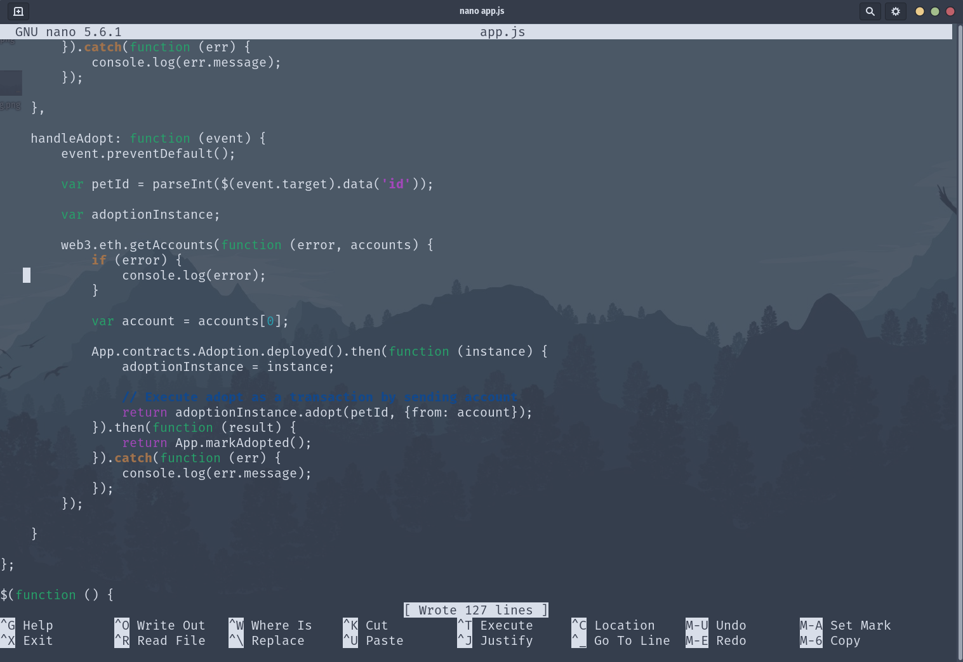

-> Interacting with the dapp in a browser

Setup and connect metamask:

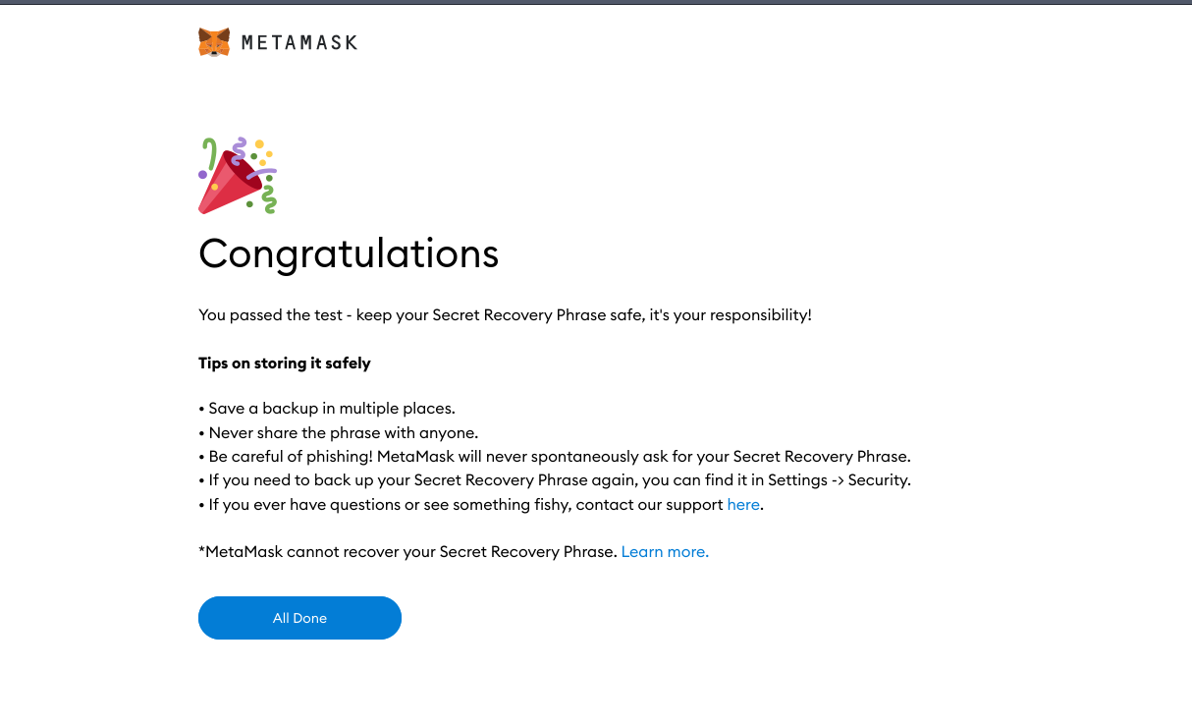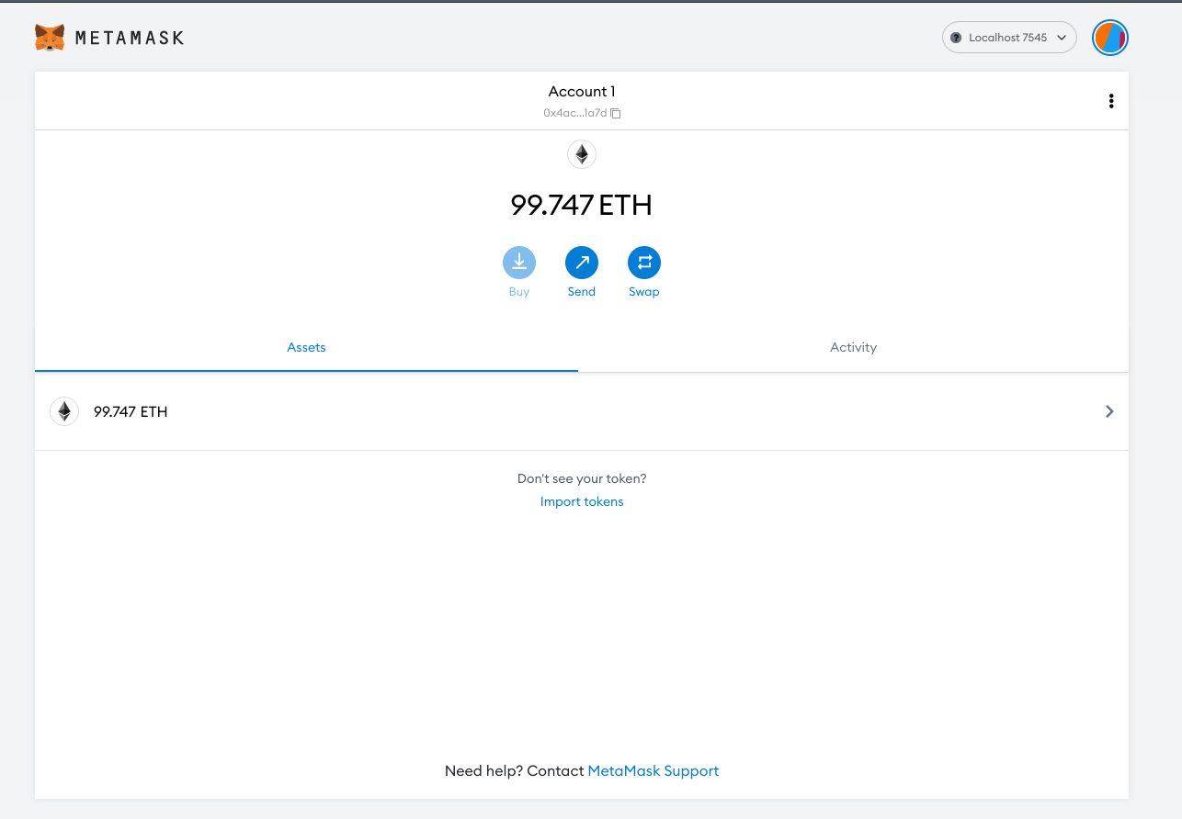

Run frontend server:

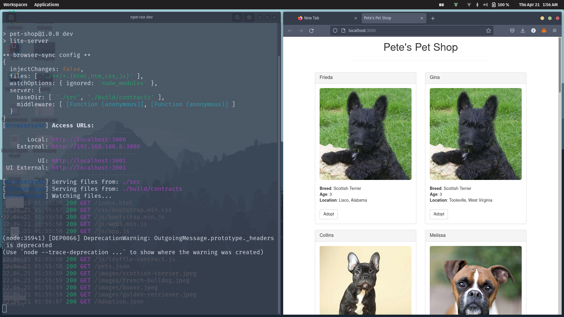

**Successful**

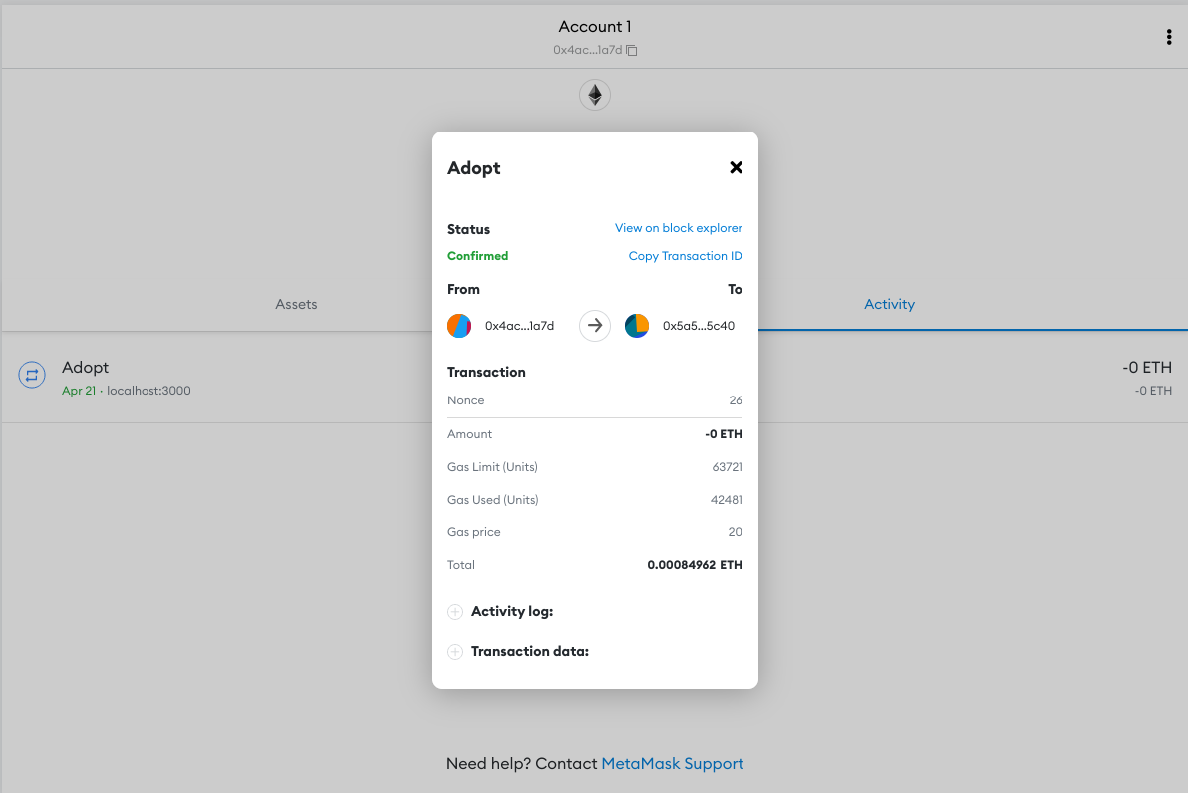

**Video Link:**

<https://drive.google.com/file/d/1ExyGFhH_xnIzBk_OcgwGyqE3Qn3OcWmF/view?usp=sharing>